# CS 255 System Design Document Template

This template lays out all the different sections that you need to complete for Project Two. Each section has guidance to prompt your thinking. You will need to continually reference the interview transcript as you work to make sure that you are addressing your client’s needs. There is no required length for the final document. Instead the goal is to complete each section based on what your client’s needs are. Remove this note when you are finished, and replace all bracketed text with the relevant information.

## UML Diagrams

### UML Use Case Diagram

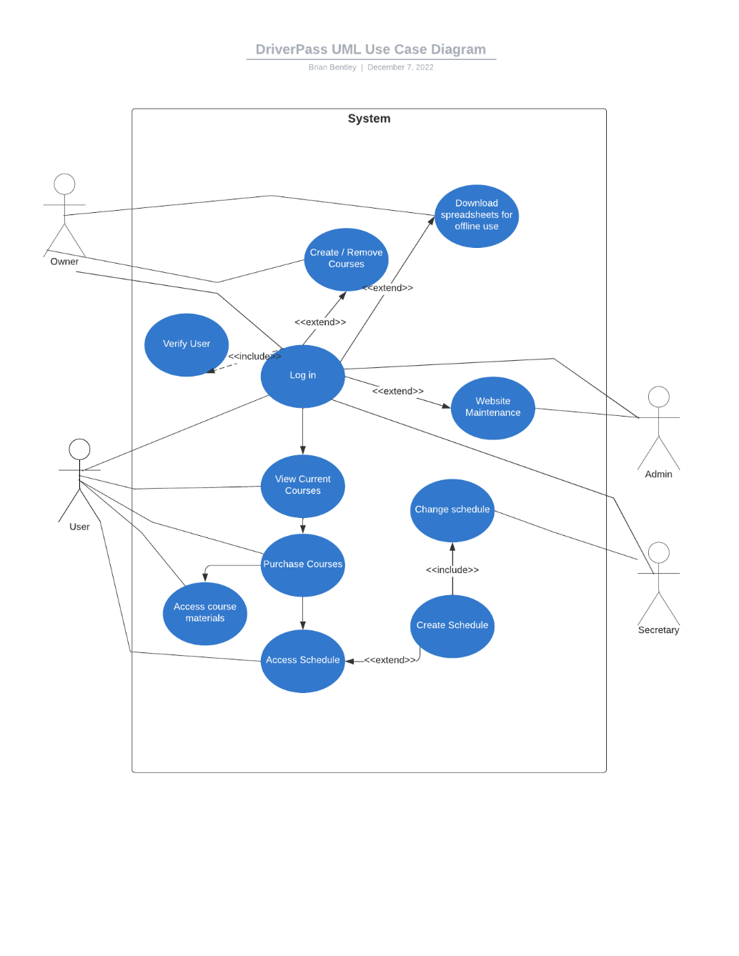

### UML Activity Diagrams

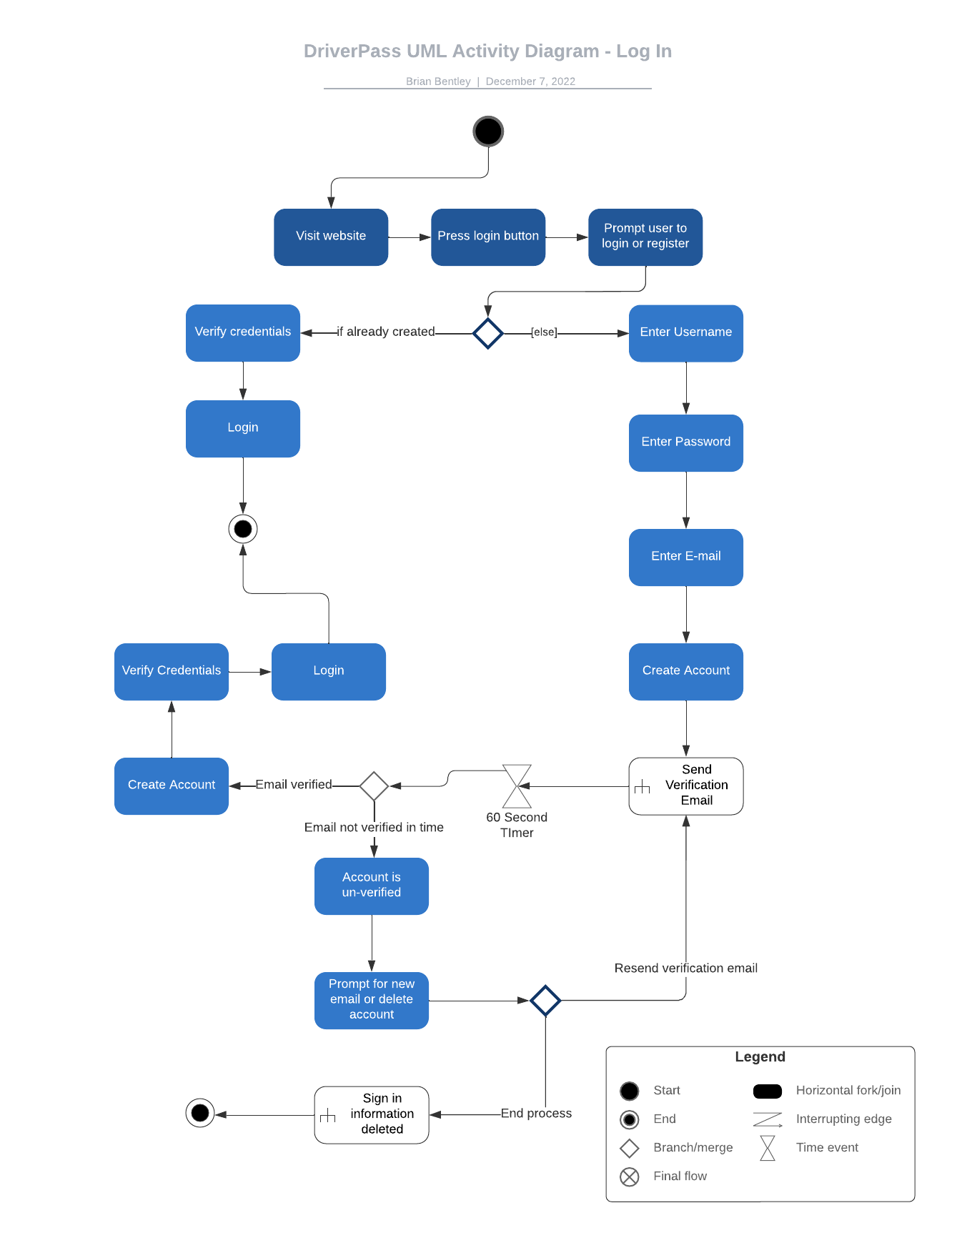

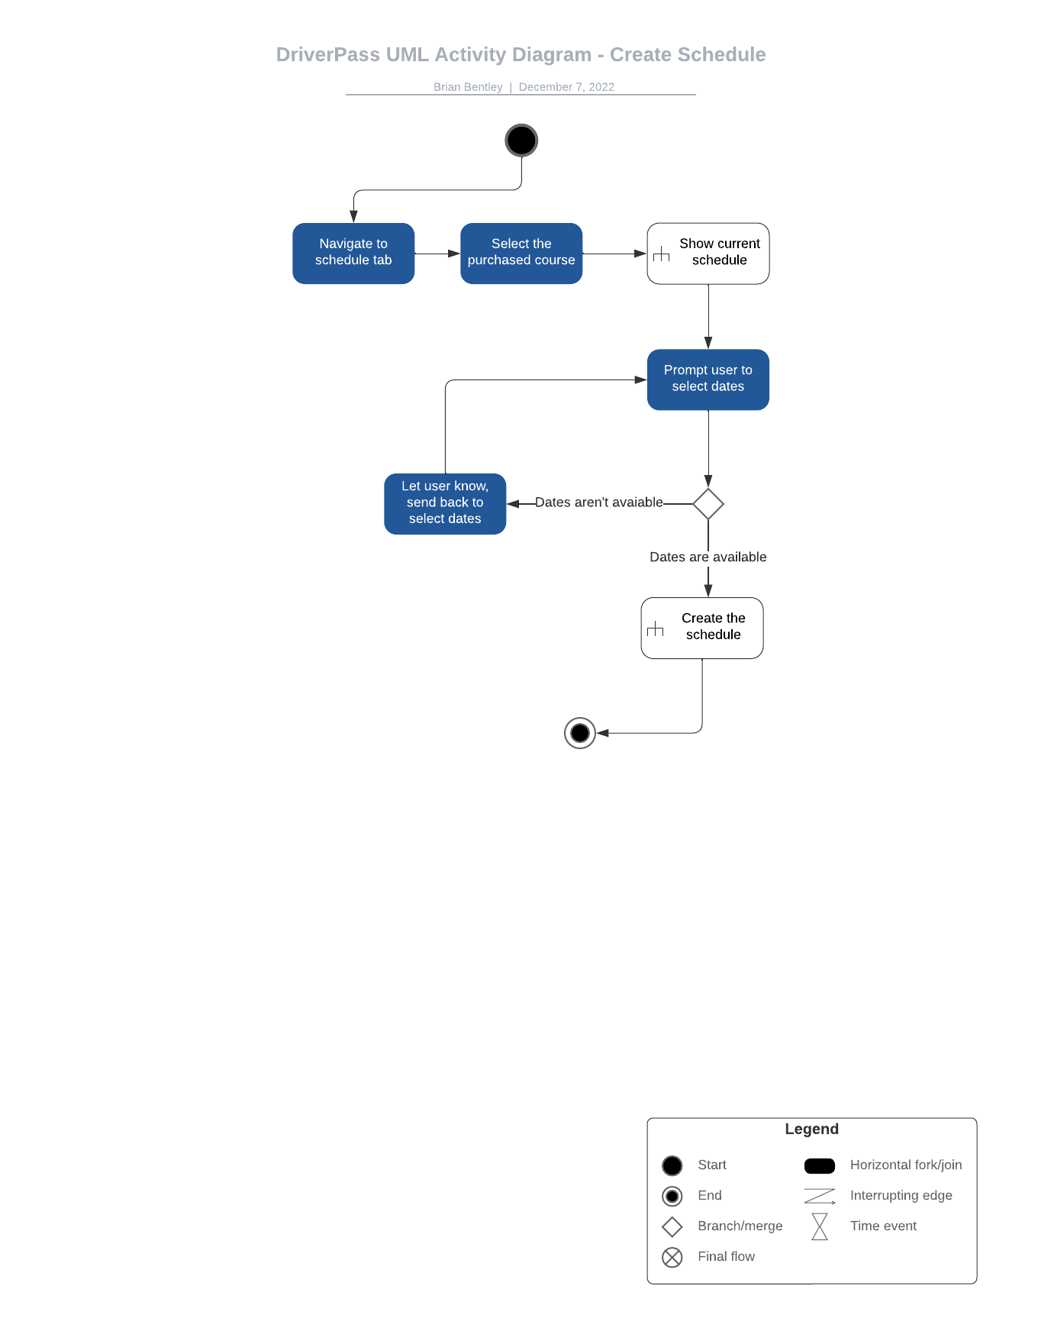

### UML Sequence Diagram

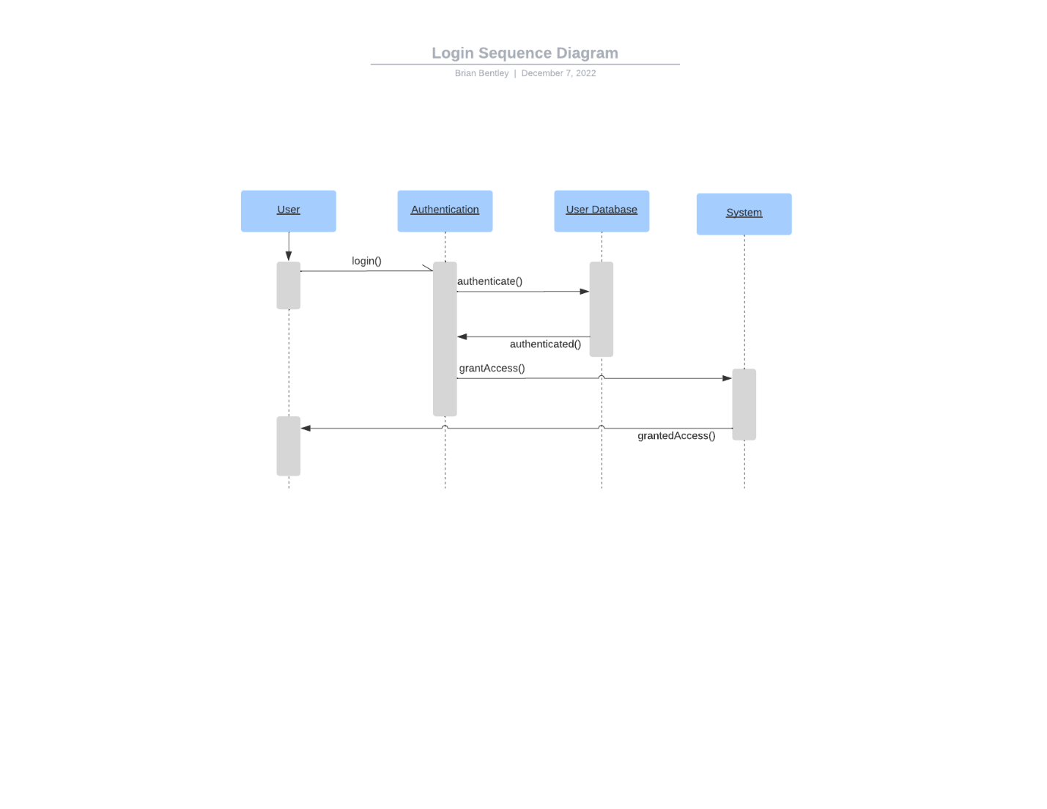

### UML Class Diagram

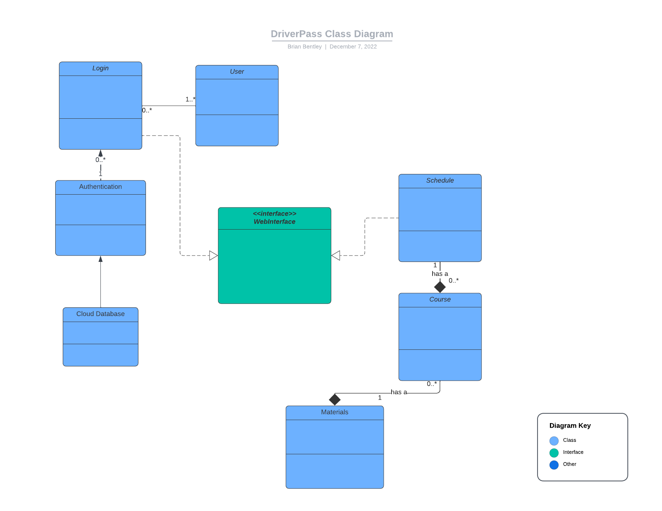

## Technical Requirements

*This system will require a cloud-based server with AWS, using their cloud software management system. We will have an admin that interfaces with AWS to help setup the actual system and ensure accessibility as well as helping maintain the system. We will use Visual Studio and AWS Cloud9 to help develop this system as tools. The software we will utilize will be the AWS DevOps and development suite such as AWS CodeCommit and AWS CodeDeploy. The system will need to also have an SQL database for the user information and credentials. It will also need passwords and sensitive information encrypted and salted. The infrastructure hardware will largely be taken care of with the cloud services through a subscription. For computer hardware for the admin we will need a PC or laptop capable of development and internet access. The owner will also need a laptop for developing schedules and other items on the go. Our secretary will need a PC or laptop as well. We will need to develop authentication software, the website front-end, the database to website interface, the course and schedule interface, and a database interface for the course materials. We will also need to develop a storefront style page that is accessible on the website that will be able to utilize secure transactions between the customer, us, and the bank.*